# **Format Computer**

**Certain Reasons Why You Should Format Your Computer:**

* Your computer cannot start because of something that you cannot trace or detect.
* Too many errors due to viruses or anything that can cause problems with your computer.
* To upgrade your Operating System.

**Steps To Use Windows Installation Media:**

1. Prepare USB Pendrive. Suggested to use Pendrive with storage capacity 16GB.
2. Download Windows installation media from <https://www.microsoft.com/en-au/software-download> .
3. Plug in your USB Pendrive to your computer.
4. Start MediaCreationTool21H2.exe downloaded previously.
5. Accept the license terms.

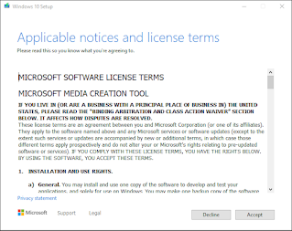

1. Choose create installation media. Click next.

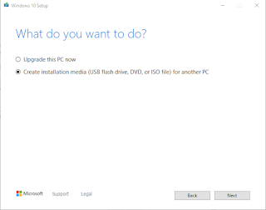

1. Use the recommended options. Click next.

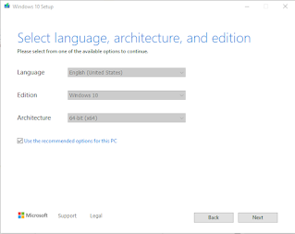

1. Choose USB flash drive. Click next.

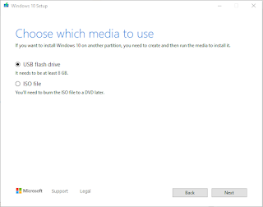

1. Click next (Remember all files inside Pendrive will be deleted).

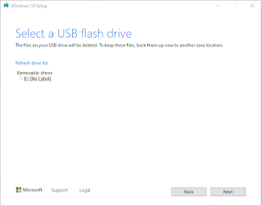

1. Let the tool download Windows image and create a bootable Pendrive.

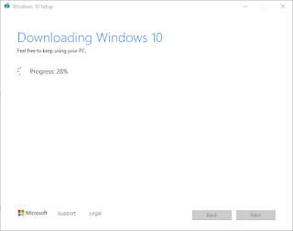

1. Click finish and your USB bootable Windows is ready.

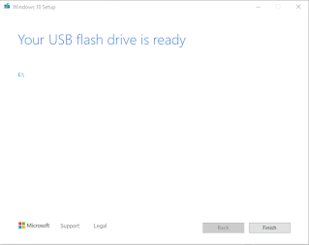

**Steps To Install Windows:**

1. Enter BIOS (Bios user interface will be different as it depends on motherboard).

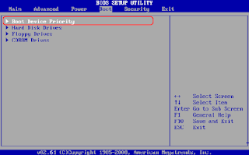

1. Assign USB Pendrive to 1st place at boot device priority.

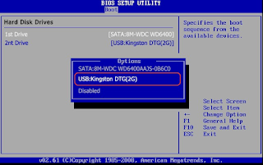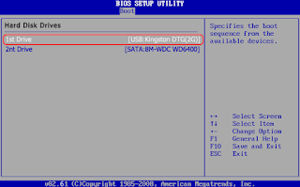

1. Save configuration and exit BIOS user interface.

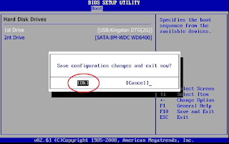

1. Your computer will restart and it will boot Windows from your USB Pendrive. Click next.

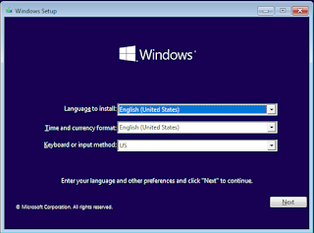

1. Click install now.

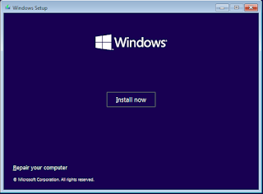

1. If you have a license key, enter it and click next. If you don't have it, just click don't have a product key and proceed.

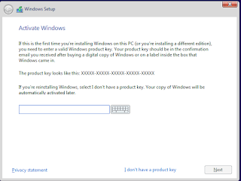

1. Choose any Windows you preferred. Click next.

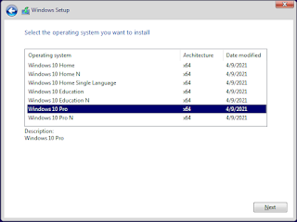

1. Accept license terms. Click next.

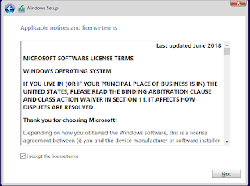

1. Choose custom install Windows only.

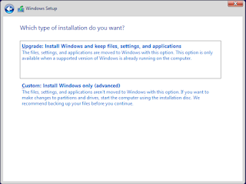

1. Click next to install Windows at the highlighted storage.

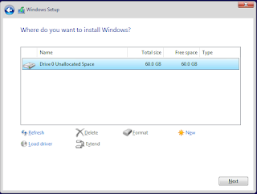

1. Windows installing. Wait until it is finished.

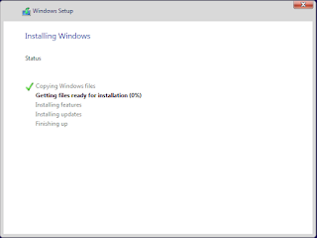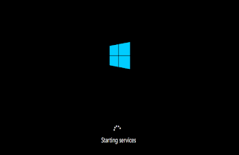

1. After the setup finishes, it will ask a few questions for your Windows.

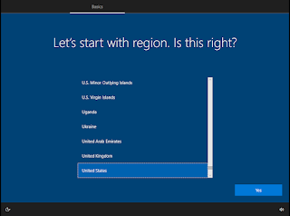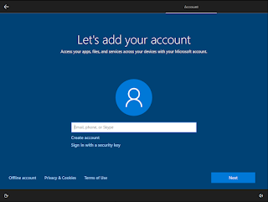

1. Done.

